The Calibration of the MOPITT instrument

Jiansheng Zou, Florian Nichitiu and James R. Drummond
Department of Physics, University of Toronto
60 St. George Street, Toronto, Ontario, CANADA, M5S 1A7

Abstract-The MOPITT (Measurements Of Pollution In The Troposphere) instrument aboard the Terra Spacecraft was launched on Dec. 18, 1999 and has operated successfully since then. Instrument radiances are calculated from a total of 8 channels, which are combined in a retrieval scheme to measure the carbon monoxide (CO) profile and methane (CH₄) column in the troposphere. The instrument gain and offset, which are the key parameters to utilize the instrument measurements and to evaluate performance, are determined through an in-flight 2-point calibration scheme. Fluctuations and trends in the gain and offset on various time scales can be understood in terms of the instrument design, its performance, and the thermal environment. Some techniques for optimizing the noise levels as well as alternative methods of data processing, such as are required to cope with instrument anomalies, will be discussed.

I. Introduction

  - The MOPITT Instrument

The MOPITT instrument is an infrared gas correlation radiometer [1]. It operates with eight channels, four CO thermal channels (channels 1,3,5,7) at a wavelength of 4.7 μm, two CO solar channels (channels 2,6) at 2.3 μm and two CH₄ solar channels (channels 4,8) at 2.2 μm. The six CO channels are combined to measure the vertical CO profile in the troposphere, while the CH₄ channels are used to derive the total column of CH₄ [2].

MOPITT utilizes Length Modulation Cells (LMCs) and Pressure Modulation Cells (PMCs) [1] to obtain a modulation of the atmospheric absorption at the particular gas spectral lines. The LMC and PMC give two-state modulation signals either through the long/short optical path alternation or through the high/low gas pressure alternation in the correlation cell. The average and the difference radiances from the two states are the product of the Level 0 (raw data) to Level 1 (radiance) data processing [3].

The calibration of the MOPITT instrument is based on the instrument design and its thermal environment. The incoming optical signal is first reflected by a scanning mirror and then goes through the chopper or is blocked by the chopper. Thereafter, the chopper-open signal passes through the LMC or PMC to produce two-state signals for the two states of the correlation cell. A beamsplitter separates the 4.7μm radiation from the shorter wavelengths, which then reach their respective detectors.

- The Terra mission, MOPITT operation and anomaly

The MOPITT instrument aboard the Terra spacecraft has collected over two years of data since the launch on Dec. 18, 1999. The Terra spacecraft flies in a sun-synchronous orbit with an exact repeat period of 16 days. The satellite circles the earth in 98.88 minutes and the orbit plane has an inclination angle of 98°, resulting in the nadir coverage of global area from 82°S to 82°N. The daytime half of the orbit follows a descending pass from the North Pole to the South Pole and crosses the equator at 10:43 am.

During nominal operation the mirrors scan in the cross-track direction. A four-pixel array for each channel covers a field of view (FOV) of 22km x 88km on the earth. Within one earth view scan the mirrors scan 29 FOVs with a 1.8° step in the look angle. After completing 10 consecutive cycles of earth view scan, the mirrors rotate 90° to view space for 5 stares. After each fifth space view event the mirrors rotate 90° again to view an internal blackbody for 20 stares. The short wave channels are calibrated by a hot source at ~460K every few months.

MOPITT has suffered two anomalies since launch. On May 7, 2001 one of the two Stirling cycle coolers, which are used to keep the detectors at about 80K, failed. The cooler fault compromised half of the instrument. After the fault, only channels 5,6,7,8 are delivering useful data. On Aug. 4, 2001 chopper 3 failed. Fortunately, it stopped in the completely open state, and we can continue to use the data by adjusting the data processing algorithm accordingly.

- The MOPITT Calibration

The signals received by the detector are digital counts and are subject to changes in the thermal environment. The purpose of the calibration is to eliminate the environmental effect and to convert the digital counts into target radiances. This is accomplished by a 2-point calibration scheme. When the instrument looks at space, where the input radiance is effectively zero, the signal received by the detector measures the integrated thermal emission from the instrument. This is the offset term (S_{sp}). Then the instrument looks at the internal blackbody (S_{bb}), where the radiance can be calculated (R_{bb}). With these two points, the gain, which measures the performance of the detector and provides the conversion from counts to radiances, can be derived: Gain = (S_{bb} – S_{sp})/R_{bb}. Here one fundamental precondition is that the count and radiance are linearly related. The target radiance is thus converted from the measured counts S by: R = (S – S_{sp})/Gain.

The MOPITT thermal (4.7μm) channels are very sensitive to the in-flight thermal environment. A frequent 2-point calibration scheme is used during nominal operation. The space view signal is sampled at interval of 130 seconds to cope with the quick thermal drift in the offset term. The blackbody view is sampled in an interval of 11 minutes immediately after a near-simultaneous measurement of space view. This is the sampling rate for the gain calculation. The blackbody is maintained at the nominal room temperature, which is suitable for all thermal channel gain calculations.

The solar channels (2.2-2.3μm) are much less sensitive to the in-flight thermal environment. The major factor affecting the solar channel gain is contamination on the cold optics in the detector nest, which is a slow process. Less frequent calibration is required. However, the blackbody has to be heated up to 460K in order to get sufficient signal. MOPITT performs the hot calibration in an interval of months, depending on how much the gain has changed.

II. The gains and offsets

- The long-term gain trend for thermal channels

Channel 7 is a typical thermal channel. It is also the only thermal channel that is unaffected by both the cooler fault and the chopper 3 fault, and we can therefore study the gain under uniform conditions for the entire mission. Fig. 1 shows two years of average gain for channel 7 pixel A from the launch to March 2002. The difference gain trend is similar to the average gain and other pixels are similar to pixel A. In the plot we took a 2-hour average for each day, neglecting fluctuations on the time scales shorter than one day. The gain trend is a sequence of segments of decreasing gain. The decrease of gain over time is caused by the ice buildup on the cold optics in the detector nest, which reduces the optical transmission. The solution to this problem is to turn the cooler off for 48 hours, which effectively heats the detector from 80K up to room temperature and thus removes the ice. Each enhancement of gain up to the initial value is the result of such an operation. Fig. 1 shows also that in the later stages of the mission the decreasing rate is noticeably reduced, implying the instrument environment is getting cleaner over time. The decontamination operation is thus required less frequently, reducing from the initial requirement of once every 3-4 months to the current annual requirement.

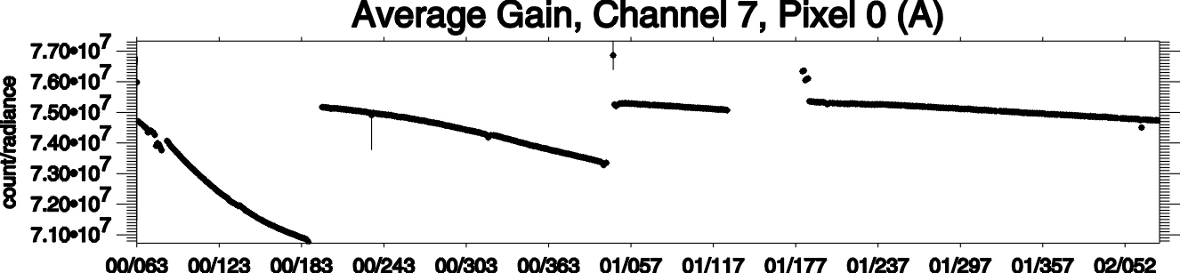

Fig. 1. The long-term average gain for channel 7 pixel A starting from the launch to March 2002. The short data gap takes place when a decontamination operation is performed and detector signals are saturated, while the long gap spans the cooler fault period.

- The in-orbit gain and offset changes for thermal channels

Fig. 2 shows a typical 2-day average gain (top panel) and offset (bottom) time series obtained at all the calibration points for channel 1 pixel A. The offset curve clearly shows a sinusoidal component at the orbital period, i.e. 98min. It was found that the peaks occur at the North Pole and the troughs at the South Pole. This exactly reflects the thermal environment variations experienced by the in-flight instrument. During daytime the satellite flies from the North Pole to the South Pole on a descending pass. The instrument is constantly illuminated by the sunlight and thus heats up. Instrument temperature reaches a maximum over the South Pole. During nighttime the opposite situation occurs. The offset also oscillates at longer time scale with a period of about 24 hours. The reason is the effect of the earth’s thermal emission on the instrument. After approximately 24 hours, the satellite returns to a path close to its original orbit. That means after 24 hours the earth “illuminates” the satellite upwards out of a similar geographical environment.

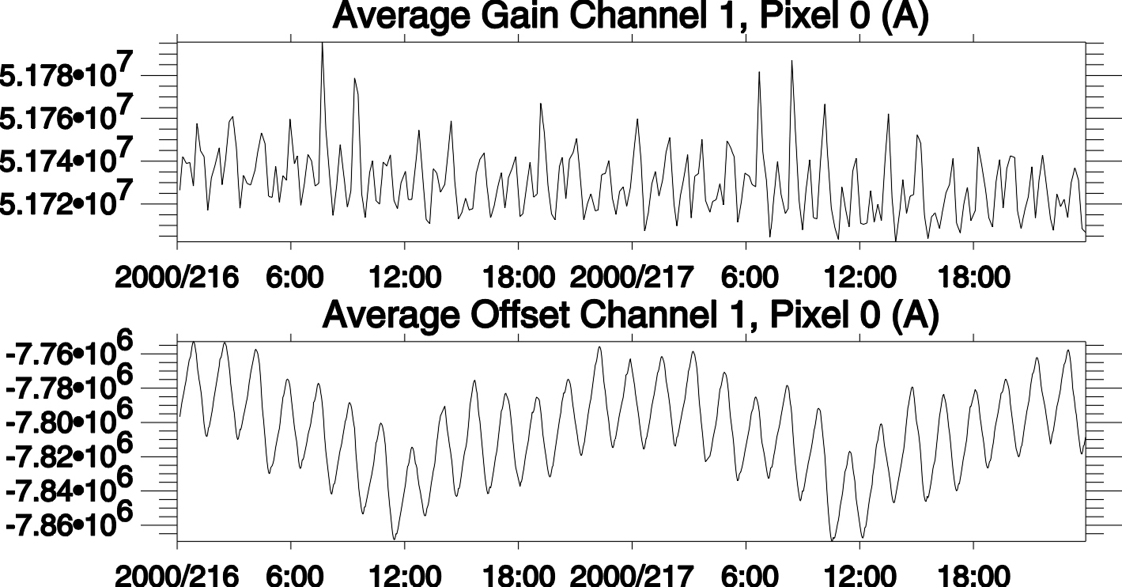

Fig. 2. A typical 4-day plot of the average gain (top panel) and offset (bottom panel) obtained for channel 1 pixel A.

The orbital variation is not present in the gain plot, which should only depend on the instrument performance rather than thermal environment changes on orbit. However, there is a small twice per orbit component in the gain curve. The peak-to-peak magnitude is about 0.1%. This is due to the fact that the blackbody is not perfect. The upward earth emission can enter the blackbody and be reflected back into the detector. The twice per orbit term is caused by the cycle of equator → pole → equator → pole → equator within one orbital period. The twice per orbit term is spurious and an orbital average can be used to remove it. The long-term decreasing trend shown in the plot is explained in the previous section.

- The solar channels

The solar channel gains have been calculated during all hot source calibration events when the blackbody is heated up to 460K. Nominally this is carried out before and after a decontamination operation. The gain at any other time is calculated by linear interpolation. Since the solar channels are insensitive to the thermal environment, the major factor affecting the gain is the contamination in the detector nest. Fig. 3 shows the normalized average gains of channel 8 pixel A obtained during the hot calibration events. Each pair of events occurs between decontamination cycles. Note in the July 13, 2000 hot calibration, there was an error in setting up the MOPITT computer, which caused a data failure for a few days, although the decontamination operation was performed successfully. For this day the hot calibration gain was instead substituted by the reference gain. The July 19, 2001 gain represents the enhanced gain by the decontamination following the cooler fault. Before that a low value gain was missing due to the cooler anomaly. The March 5, 2002 gain adds an extra point, before the next decontamination in several months is required. Despite only a few discrete points in the plot, the pattern and trends in the gain changes are all similar to those seen in the thermal channels.
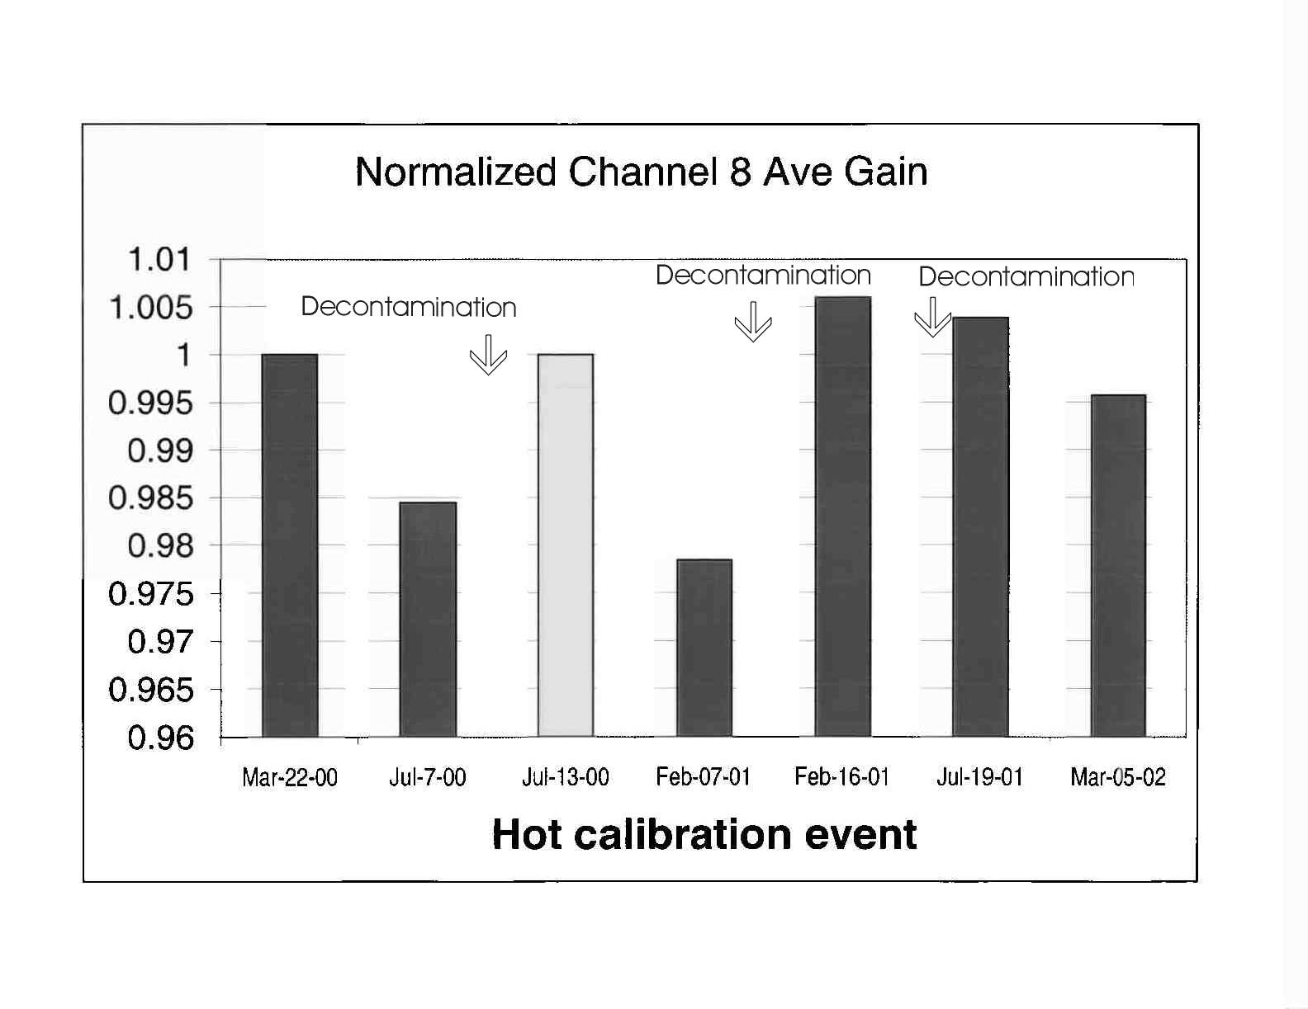
Fig. 3 The normalized average gains for channel 8 pixel A obtained during the hot calibration events.

- A test for the linearity between counts and radiances

The 2-point calibration is based on the precondition that the gain is independent of target temperature. This precondition can be tested for the solar channel using the calibration data set with the blackbody temperature increasing from room temperature to 460K. The result shows that there is a fluctuation in the daytime gain at 0.5%, but the nighttime gain remains more stable throughout the heating period. For the solar channels we ought to use the nighttime gain and offset, which effectively eliminates any possible influence from sunlight, and use them to convert the daytime earth scene digital counts to radiances.

III. The Noise level assessment

TABLE I
The Noise Equivalent Radiance Obtained from MOPITT Data (W/m2/sr)

“Cha” stands for channel, “SP” for space view, “BB” for blackbody view, “Ave” for average radiance, “Dif” for difference radiance.

The noise level of the MOPITT radiance is an important parameter in the retrieval algorithm for converting radiances to CO or CH₄ concentrations. The noise equivalent radiance (NER) needs to be estimated from the calibrated radiance. The scientific requirement for the MOPITT mission is the ability to detect a 10% change in CO and a 1% change in CH₄. This requires the NER for each channel to be below a certain level [1]. Table 1 gives one example of estimated NERs obtained from the space view and blackbody view for each channel at one pixel. A detailed description for the calculation can be found in [4]. The calculation was made from a 2-hour granule data set. Therefore these values at least reflect the magnitude of the NER values. In general, the NERs at the blackbody view are comparable to the NERs at the space view. They are comparable to the required values as specified in [1] except for the PMC channels 3, 7, where the NERs are higher than required. Analysis of sector level data shows that the excessive noise level in PMC channels lies on the data processing side rather than the instrument performance side. The MOPITT NCAR (National Center for Atmospheric Research) team in Boulder, Colorado has found a method for solving this problem. In addition, for the solar channels the NER estimated from the calibration source may not represent the NER at the earth scenes because of the possible rapid change in the surface reflectivity during one stare (450 milliseconds). Further investigations in this field are essential towards making full use of the solar channel data.

IV. Conclusions

The MOPITT data are being successfully calibrated using the current operational scheme. These results provide a fundamental framework for the retrieval process. They are also invaluable in planning for future missions. Using the calibrated MOPITT radiance the NCAR team has generated CO profile data. They are available for the public at the NASA Langley Research Center (http://eosweb.larc.nasa.gov).

Acknowledgement

The MOPITT project is funded by the Canadian Space Agency (CSA). The MOPITT data analysis is funded by the National Sciences and Engineering Research Council of Canada and the Meteorological Service of Canada.

References

[1] J.R. Drummond, MOPITT Mission Description Document, Toronto, ON: The University of Toronto, 1996.
[2] NCAR MOPITT team, MOPITT algorithm theoretical basis document: Retrieval of carbon monoxide profiles and column amounts of carbon monoxide and methane from MOPITT observed radiances (Level 1 to Level 2). Boulder, CO: The National Center for Atmospheric Research, 1996.
[3] University of Toronto and NCAR MOPITT team, MOPITT algorithm theoretical basis document: Conversion of MOPITT digital counts into calibrated radiances in carbon monoxide and methane absorption bands (Level 0 to Level 1). Toronto, ON: The University of Toronto, 1996.
[4] J. Zou, Processing of MOPITT data, Part I: The thermal channels. Toronto, ON: The University of Toronto, 2001.

